

**LAB Report**

**COURSE TITLE –** Microprocessor Lab

**COURSE CODE –** CSE 360

***Submitted To***

***Md. Ismail***

*Lecturer of UITS*

***Submitted By***

*Md. Shoyaif Rahman (****0432310005101050****)*

***Semester:*** *Autumn-2025 (6th)*

***Department:*** *CSE*

***Batch:*** *53*

***Section:****6A2*

Date: 27/08/25

Assembly Language Lab Report

# Lab report: 02

# Experiment Name: addition and difference of two numbers Assembly Language

## Process

**Adding two numbers:**

1. Read **first number** from user (single character).
2. Move cursor to a **new line**.
3. Read **second number** from user (single character).
4. Add the two numbers and adjust ASCII (sub 48).
5. Move cursor to a **new line**.
6. Print the **result**.

**subtracting two numbers:**

1. Read **first number** from user (single character).
2. Move cursor to a **new line**.
3. Read **second number** from user (single character).
4. Add the two numbers and adjust ASCII (sub 48).
5. Move cursor to a **new line**.
6. Print the **result**.

## 2. Implementation (Program Code – ASM)

1.Adding two numbers

org 100h

mov ah,1

int 21h

mov bl,al

mov ah,2

mov dl,010

int 21h ;new line

mov dl,013

int 21h

mov ah,1

int 21h

mov bh,al

add bl,bh

sub bl,48

mov ah,2

mov dl,010

int 21h ;new line

mov dl,013

int 21h

mov ah,2

mov dl,bl

int 21h

ret

**output:**

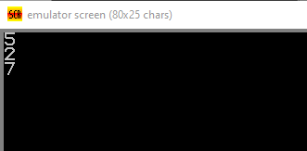

2.Subtrating two numbers

org 100h

mov ah,1

int 21h

mov bl,al

mov ah,2

mov dl,010

int 21h ;new line

mov dl,013

int 21h

mov ah,1

int 21h

mov bh,al

sub bl,bh

add bl,48

mov ah,2

mov dl,010

int 21h ;new line

mov dl,013

int 21h

mov ah,2

mov dl,bl

int 21h

s

ret

**output:**

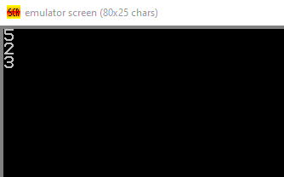

• The program correctly reads two single-digit numbers from the user.

**3.Result**

• For the **addition program**, the sum of the two input numbers is displayed as output.

* Example: Input 4 and 3 → Output 7.

• For the **subtraction program**, the difference between the two input numbers is displayed as output.

* Example: Input 8 and 5 → Output 3.

• Both programs successfully handle ASCII to numeric conversion and display results on a new line.

## 4. Conclusion

1. We successfully took two numbers as input from the user using INT 21h, AH=1.
2. In the **first program**, we performed **addition** of two ASCII digits and displayed the result using INT 21h, AH=2.
3. In the **second program**, we performed **subtraction** of two ASCII digits and displayed the result.
4. Learned how to handle **ASCII to numeric conversion** (sub 48) for addition and **numeric to ASCII conversion** (add 48) for subtraction.
5. Used **Line Feed (10h) and Carriage Return (13h)** to print outputs neatly on a new line.
6. This demonstrates basic arithmetic operations and output formatting in **8086 Assembly**.